The title should be written in Arial Bold Font Size 14
J.B. Yang¹, M. Yue², A.R.Yan³, M.G. Zhu⁴ and X.L. Rao⁵ (Arial Bold Font Size 11)
¹ School of Physics, Peking University, Beijing, 100871, P.R. China (Arial Font Size 10)
² Beijing University of Technology, Beijing, 100124, P.R. China (Arial Font Size 10)
³ Ningbo Institute of Industrial Technology, CAS, Ningbo, Zhejiang Province, 315201 P.R.China (Arial Font Size 10)
⁴ Zhong Ke San Huan Hi. Tec. Co. LTD, Beijing, 100190,P.R.China (Arial Font Size 10)
⁵ China Iron& Steel Research Institute Group, Beijing, 100081, P.R.China (Arial Font Size 10)

Abstract (Arial Bold Underline Font Size 10)
Please write your full paper using this template. Before you submit your proceeding paper please double check that the layout is exactly the same as in this document. Otherwise we have to send you back the manuscript. Use the style sheets (Title, Caption, and Text) installed in Microsoft Word. The paper should not exceed 5-10 pages. The abstract and the normal text should be written in Arial Font Size 10 with single line spacing.
Keywords (Arial Bold Underline Font Size 10): Nd-Fe-B, permanent magnet

1. Introduction (Arial Bold Underline Font Size 10)
For citations use the Journal of Magnetism Magnetic Materials Style which you can download using this link: http://endnote.com/downloads/style/journal-magnetism-and-magnetic-materials and implement vie endnote. This means e.g. within the text citations should be numbered in ascending order and written in angular brackets [1].

2. Experimental (Arial Bold Underline Font Size 10)
This part describes the experimental set-up and measurement methods used.

3. Results and discussion (Arial Bold Underline Font Size 10)

3.1.Magnetic measurements (Arial Italic Underline Font Size 10)
If you would like to implement a formula use the mathematic mode and indicate the formula with ascending numbers in round brackets:
$$λ=\frac{J_{r}-J_{r}^{hard}}{J_{r}}$$ | (1)
If you would like to implement a table place the caption above the table.

Tab. 1. Here is a caption of a table (above the table) in Arial Font Size 9.
sample | H_{c} (T) | J_{r} (T)
1 | 2 | 1.1
2 | 3 | 1.2
3 | 4 | 1.3

If you would like to implement a figure consisting of different subfigures use (a) and (b) for indication. The caption should be below the figure and describe all symbols shown in the figure. Furthermore you have to use png or jpg format for your figure.

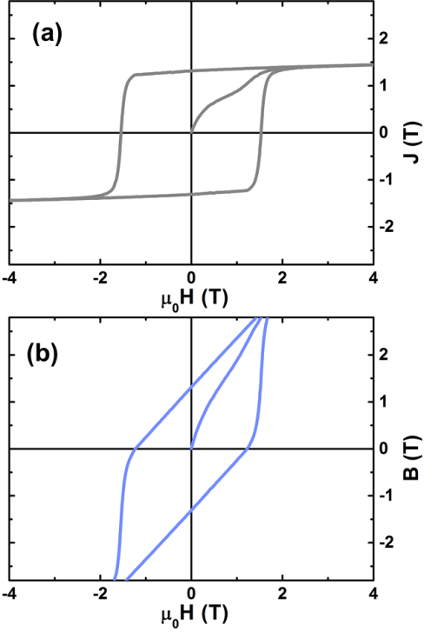
Fig. 1. Here is a caption of a figure in Arial Font Size 9 showing a (a) M-H and (b) B-H hysteresis curve.

4. Conclusion (Arial Bold Underline Font Size 10)
The conclusion should summarize and conclude the work.

Acknowledgement (Arial Bold Underline Font Size 10)
Some space for the acknowledgement.

References (Arial Bold Underline Font Size 10)
In the section “references” all authors should be mentioned with abbreviated first names as shown below. Also the name of the journal should be abbreviated. The title should be included.
For citations use the Journal of Magnetism Magnetic Materials Style which you can download using this link: http://endnote.com/downloads/style/journal-magnetism-and-magnetic-materials and implement vie endnote. This means e.g. all authors should be mentioned with abbreviated first names as shown below. Also the name of the journal should be abbreviated. The title should be included.

[1] J.B. Yang, M. Yue, A.R. Yan, M.G. Zhu and X.L. Rao, High performance permanent magnets, J. Magn. Magn. Mater. 1999 (2199) 1-3.

